[Tutorials for courses]

Technical Document

Date:2/Mar/2018

Version: Version 0.1

# Table of Contents

Table of Contents 1

[tutorials] 2

Description 2

1.1 Mockup screen: 2

1.2 Angular & Spring Models 3

1.3 Angular Component 3

1.4 Rest Services 3

1.5 Flow Services: 4

1.6 Repository Functions 4

# 

# [Tutorials]

Refer to: [Taiga URL]

## Description

Add articles to a specific course .

## Mockup screen:

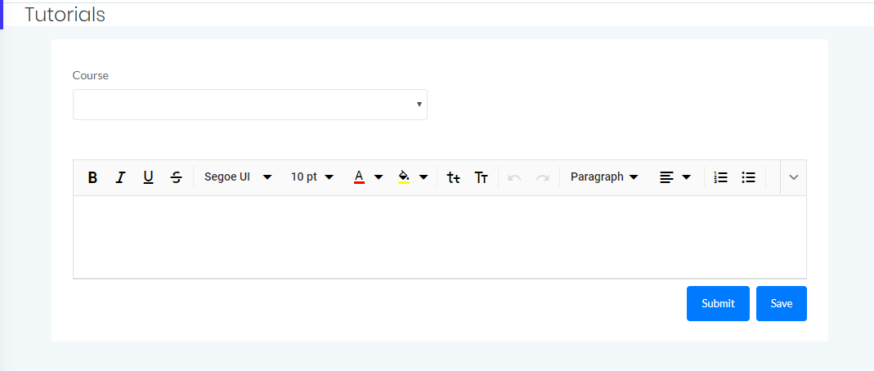

## Angular & Spring Models

🡪 Use For Get Instructor Courses

|  |  |  |
| --- | --- | --- |
| **Use** | **Class Name** | CourseVTO |
| **Angular Path** | | app/modules/course/shared/data/course-vto.data.ts |
| **Spring Path** | | model/course/CourseVTO |

|  |  |  |  |  |
| --- | --- | --- | --- | --- |
| **New** | **Class Name** | LectureDTO | | |
| **Angular Path** | | app/modules/course/shared/data/lecture-dto.data.ts | | |
| **Spring Path** | | model/course/ LectureDTO | | |
| **Fields** | | | | |
| **Attribute** | | | **Angular Data Type** | **Spring Data Type** |
| course_id | | | number | int |
| value | | | string | string |

## Angular Component

|  |  |  |
| --- | --- | --- |
| **New** | **Class Name** | TutorialsComponent |
| **Path** | | app/modules/course/components/tutorials/tutorials.component.[ts/html] |

🡪get courses from database

|  |  |  |
| --- | --- | --- |
| **use** | **Class Name** | CourseService |
| **Path** | | app/modules/course/shared/course.service.ts |
| **Function** | | 1. findAllInstructorsCourses (data: CourseVTO) 2. createLecTutorial(data: LecDTO) |

## Rest Services

|  |  |  |  |  |
| --- | --- | --- | --- | --- |
| **use** | **Name** | api/course/cor_ID/instructor/inst_ID | **Method** | GET |
| **Controller** | | CourseRes | **Function** | findAllInstructorCourses (instructorID) |

|  |  |  |  |  |  |  |  |
| --- | --- | --- | --- | --- | --- | --- | --- |
| **New** | **Name** | | api/course/cor_ID/lec/lec_ID  /tutorial/new | | | **Method** | POST |
| **Controller** | | | CourseRes | | | **Function** | createLecTutorial (cor_ID,lec_ID) |
| **REST Parameter** | | | | | | | |
| **Attribute** | | **Parameter Type** | | **Data Type** | **Description** | | |
| data | | PathParmeter | | LecDTO |  | | |

## Spring Service:

|  |  |  |  |  |
| --- | --- | --- | --- | --- |
| **New** | **Class Name** | CourseSer | **Function** | createLecTutorial (cor_ID,lec_ID) |
| **Description** | | Add New Article | | |

## Spring Repository:

|  |  |  |  |  |
| --- | --- | --- | --- | --- |
| **New** | **Class Name** | CourseRep | **Type** | Insert SQL |
| **Function** | | insertLecTutorial (CourseDTO data) | | |
| **Query** | | | | |
| INSERT INTO lecture (cor_ID ,tutorial_val ) VALUES (?,?)  Where cor_id = ?  And lec_id = ? | | | | |

|  |  |  |  |  |
| --- | --- | --- | --- | --- |
| **use** | **Class Name** | CourseRep | **Type** | select SQL |
| **Function** | | findAllInstructorCourses  (int instructorID) | | |

## ER Diagram: